**SETTING UP FRAMEWORK FROM SCRATCH USING SPECFLOW & SELENIUM WITH VISUAL STUDIO IDE**

C#

1. DOWNLOAD AND INSTALL VISUAL STUDIO
2. INTERGRATE SPECFLOW EXTENSION WITH VISUAL STUDIO IDE
3. CREATE NEW TEST PROJECT
4. CREATE FOLDER STRUCTURE
5. ADD NUGGET PAKAGES
6. CREATE FIRST FEATURE FILE & STEP DEFINITION

ii. CREATE YOUR PAGE OBJECT

iii. CREATE YOUR UTILITIES

1. WRITE YOUR CODES & RUN YOUR TEST

**STEP 1- DOWNLOAD AND INSTALLING VISUAL STUDIO**

**GO TO**[**https://visualstudio.microsoft.com/**](https://visualstudio.microsoft.com/)

CLICK ON DOWNLOAD FOR WINDOWS

AND CLICK ON COMMUNITY 2017(ITS A FREE VERSION)

[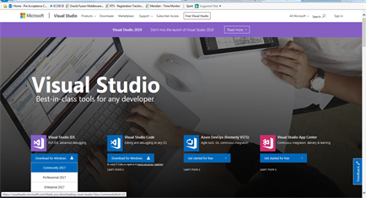](https://user-images.githubusercontent.com/46799533/55685326-af015f00-594c-11e9-9b79-71a1734aff1e.png)

IT SHOULD START TO DOWNLOAD

DURING THE INSTALLATION IT WILL ASK YOU WHAT TI INSTALL

CHECK THE .NET DESKTOP DEVELOPMENT

THEN ISTALLATION CONTINUE

THEN IT WILL ASK YOU TO RESTART YOUR SYSTEM

**STEP 2- INTERGRATE SPECFLOW EXTENSION WITH VISUAL STUDIO IDE**

(For SpecFlow to properly work on VS2017, we need to add the SpecFlow as an extension to VS)

On Visual Studio

Select Tools

Select Extensions and updates

[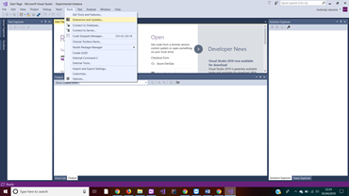](https://user-images.githubusercontent.com/46799533/55685413-c9880800-594d-11e9-9a30-1da31598df09.png)

From the menu in visual Studio

Click/switch to **online** on the left

Enter **“SpecFlow”** in the search in the search field on the top right

Click download to start **“downloading”** the extension

[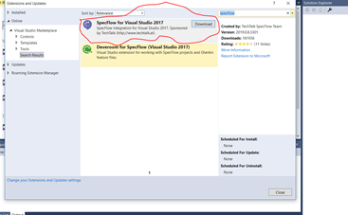](https://user-images.githubusercontent.com/46799533/55685426-ff2cf100-594d-11e9-8679-1f4c8b33b210.png)

**NOTE- THIS IS VERY IMPORTANT AS YOU ONLY DO IT ONCE FOR YOUR VISUAL STUDIO. IF YOU HAVE A NEW LAPTOP YOU WILL HAVE TO DO IT AGAIN WHEN YOU INSTALL VISUAL STUDIO**

**Then restart your system**

**STEP 3-CREATE NEW TEST PROJECT**

Click **File**

Click **New**

Click **Project**

[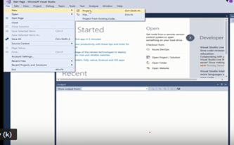](https://user-images.githubusercontent.com/46799533/55685458-719dd100-594e-11e9-9e34-aa2f2a8fd22c.png)

Select **Test**

Select **Unit test project**

[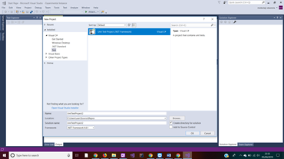](https://user-images.githubusercontent.com/46799533/55685470-a3af3300-594e-11e9-8632-d8e8430bdd78.png)

Enter the name of the **Project i.e Testing**

Browse to store the **Project** in a folder

Check **create directory for solution** to create a folder for the solution

Click ok

And your solution will be created

**STEP 4-CREATE FOLDER STRUCTURE**

Right click on the **Project- Testing (Note-the solution)**

Select **Add**

Select **New folder**

[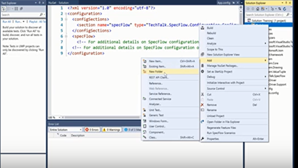](https://user-images.githubusercontent.com/46799533/55685525-1c15f400-594f-11e9-9165-fb80b285385b.png)

**Create the following folders:**

1. Features
2. PageObjects
3. StepDefinitions
4. Utilities

• **Features**- (This is where SpecFlow feature files will be stored)

• **PageObjects**-(This will store different classes for each of the page that you will be inspecting)

• **StepDefinitions**-( From you Feature file you will creating some steps. You steps will gi into Step definition folder)

• **Utilites-** (Called helper classes will contain any class or file that is not in the three above will be stored here)

**STEP 5- ADD NUGGET PAKAGES**

Right click on Solution

Click on manage Nugget packages

[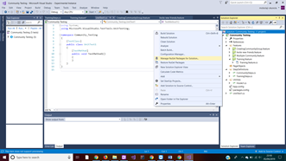](https://user-images.githubusercontent.com/46799533/55685543-6ac38e00-594f-11e9-890c-6077b2b240d1.png)

Click on Browse

In the search box ,search for the packages i.e SpecFlow

Select SpecFlow and click install.

Add the following required 11 packages;

• Nunit

• NUnit.Console

• NUnit3TestAdapter

• **SpecFlow (Version- 2.4.1)**

• **SpecFlow.Nunit(Version- 2.4.1)**

• Selenium.WebDriver

• Selenium.Support

• Selenium.WebDriver.IEDriver

• Selenium.Firefox.WebDriver

• Selenium.WeDriver.ChromeDriver

Arrow down will show a package has been installed

**STEP 6.1-CREATE FIRST FEATURE FILE & STEP DEFINITION**

• Right click on Features

• Click on Add New Item

Select SpecFlow on the left and select SpecFlow Feature file(**if you don’t see it that mean you have not integrate SpecFlow with your Visual Studio. What you need to do back to STEP 2 to integrate Specflow.**)

[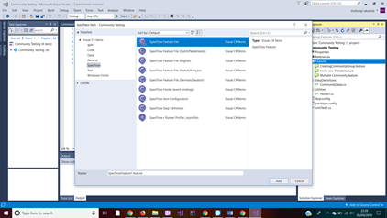](https://user-images.githubusercontent.com/46799533/55685570-d9a0e700-594f-11e9-9ee7-5113dd572f5e.png)

• Write the name of your Test i.e Registration and click add

• Your Feature file will displayed with examples of what is expected

• Delete the steps and write your own steps and scenario using (GIVEN,WHEN,AND,THEN).

• Right click on any of the purple step and click Generate Step Definition

[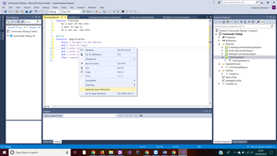](https://user-images.githubusercontent.com/46799533/55685589-02c17780-5950-11e9-8048-73db03fbeb8c.png)

It should display this window

[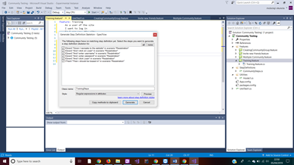](https://user-images.githubusercontent.com/46799533/55685611-24226380-5950-11e9-9387-22c6c7744bdd.png)

Click generate and save it in Step Definition folder under your project. The steps will change from purple to black or white.

[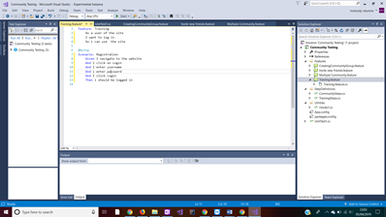](https://user-images.githubusercontent.com/46799533/55685618-40260500-5950-11e9-8755-e518d978f4f6.png)

The steps will show on the right under step definition folder

[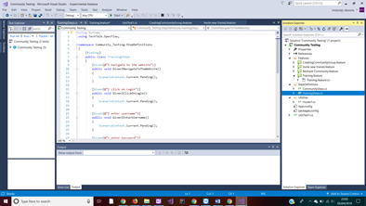](https://user-images.githubusercontent.com/46799533/55685641-6186f100-5950-11e9-84eb-3049d60bc28e.png)

**STEP 6.2- CREATE YOUR PAGE OBJECT**

• Right click on PageObject

• Click on Add New Item

• Click on code on the left

• And select Class

[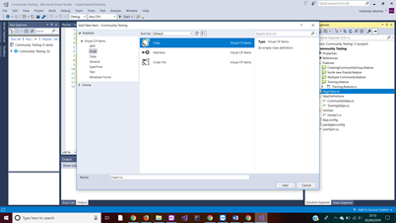](https://user-images.githubusercontent.com/46799533/55685657-93985300-5950-11e9-8ac8-ebef9422ce97.png)

• Rename Class to your project name e.g. TestingPage

• And click Add

[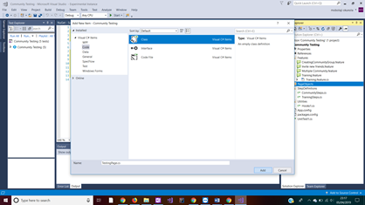](https://user-images.githubusercontent.com/46799533/55685664-b1fe4e80-5950-11e9-8b36-6bf784b889d3.png)

You should see the screen below

[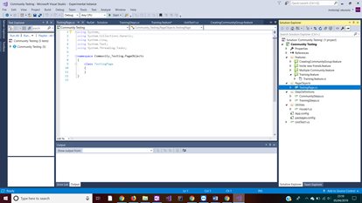](https://user-images.githubusercontent.com/46799533/55685671-ccd0c300-5950-11e9-9182-19b2c41e6270.png)

**STEP 6.3- CREATE YOUR UTILITIES(HOOKS)**

• Right click on Utilities

• Click on Add New Item

• Click on Specflow on the left

• And select Specflow Hook (Event Binding)

• And click Add

[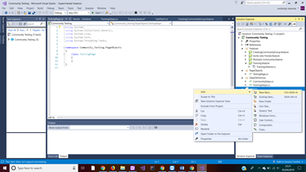](https://user-images.githubusercontent.com/46799533/55685692-1ae5c680-5951-11e9-911b-8f075ba75c7e.png)

[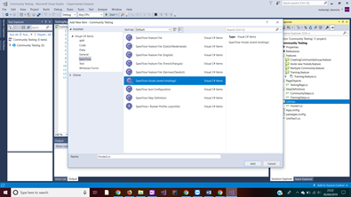](https://user-images.githubusercontent.com/46799533/55685702-3224b400-5951-11e9-9037-bdf0abe970f1.png)

You should see the screen below

[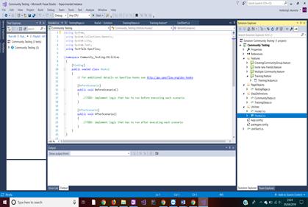](https://user-images.githubusercontent.com/46799533/55685711-60a28f00-5951-11e9-84cb-9524b773a05e.png)

**WRITE YOUR CODES & RUN YOUR TEST**